Name:Mahizebin Shams-E-Mofiz

ID: 1712634642

1.Ohm’slaw: The law that for any circuit the electric current is directly proportional to the  voltage and is inversely proportional to the resistance.

Georg Ohm found that, at a constant temperature, the electrical current flowing through a fixed linear resistance is directly proportional to the voltage applied across it, and also inversely proportional to the resistance. This relationship between the Voltage, Current and Resistance forms the basis of Ohms Law and is shown below.

**Ohms Law Relationship**

1. ohms law

By knowing any two values of the Voltage, Current or Resistance quantities we can use **Ohms Law** to find the third missing value. Ohms Law is used extensively in electronics formulas and calculations so it is “very important to understand and accurately remember these formulas”.

To find the Voltage, ( V )

[ V = I x R ]      V (volts) = I (amps) x R (Ω)

To find the Current, ( I )

1. [ I = V ÷ R ]      I (amps) = V (volts) ÷ R (Ω)

To find the Resistance, ( R )

1. [ R = V ÷ I ]      R (Ω) = V (volts) ÷ I (amps)

It is sometimes easier to remember this Ohms law relationship by using picture.

### Ohms Law Pie Chart

1. 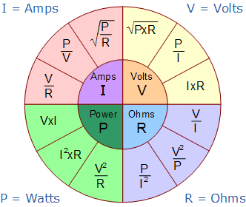

**2. Internal structure of a resister:**

There are many different types of resistor each with there own method of construction. The construction method generally depends on the demand of the application. For example for circuits requiring low error (like sensors) a thin film type may be the best construction. Alternatively, for high power wirewound resistors and thich film resistors are the most common. Resistors can be either fixed or variable. The low power resistors are comparatively smaller in size than high power resistors. The resistance of a resistor can be estimated by their colour codes or can be measured by a multimeter. There are some non linear resistors also whose resistance changes with temperature or light. Negative temperature coefficient (NTC), positive temperature coefficient (PTC) and light dependent resistor ([LDR](http://engineersgarage.com/content/ldr)) are some such resistors. These special resistors are commonly used as sensors. Read and learn about internal structure and working of a [resistor](http://www.engineersgarage.com/insight/how-resistor-works).